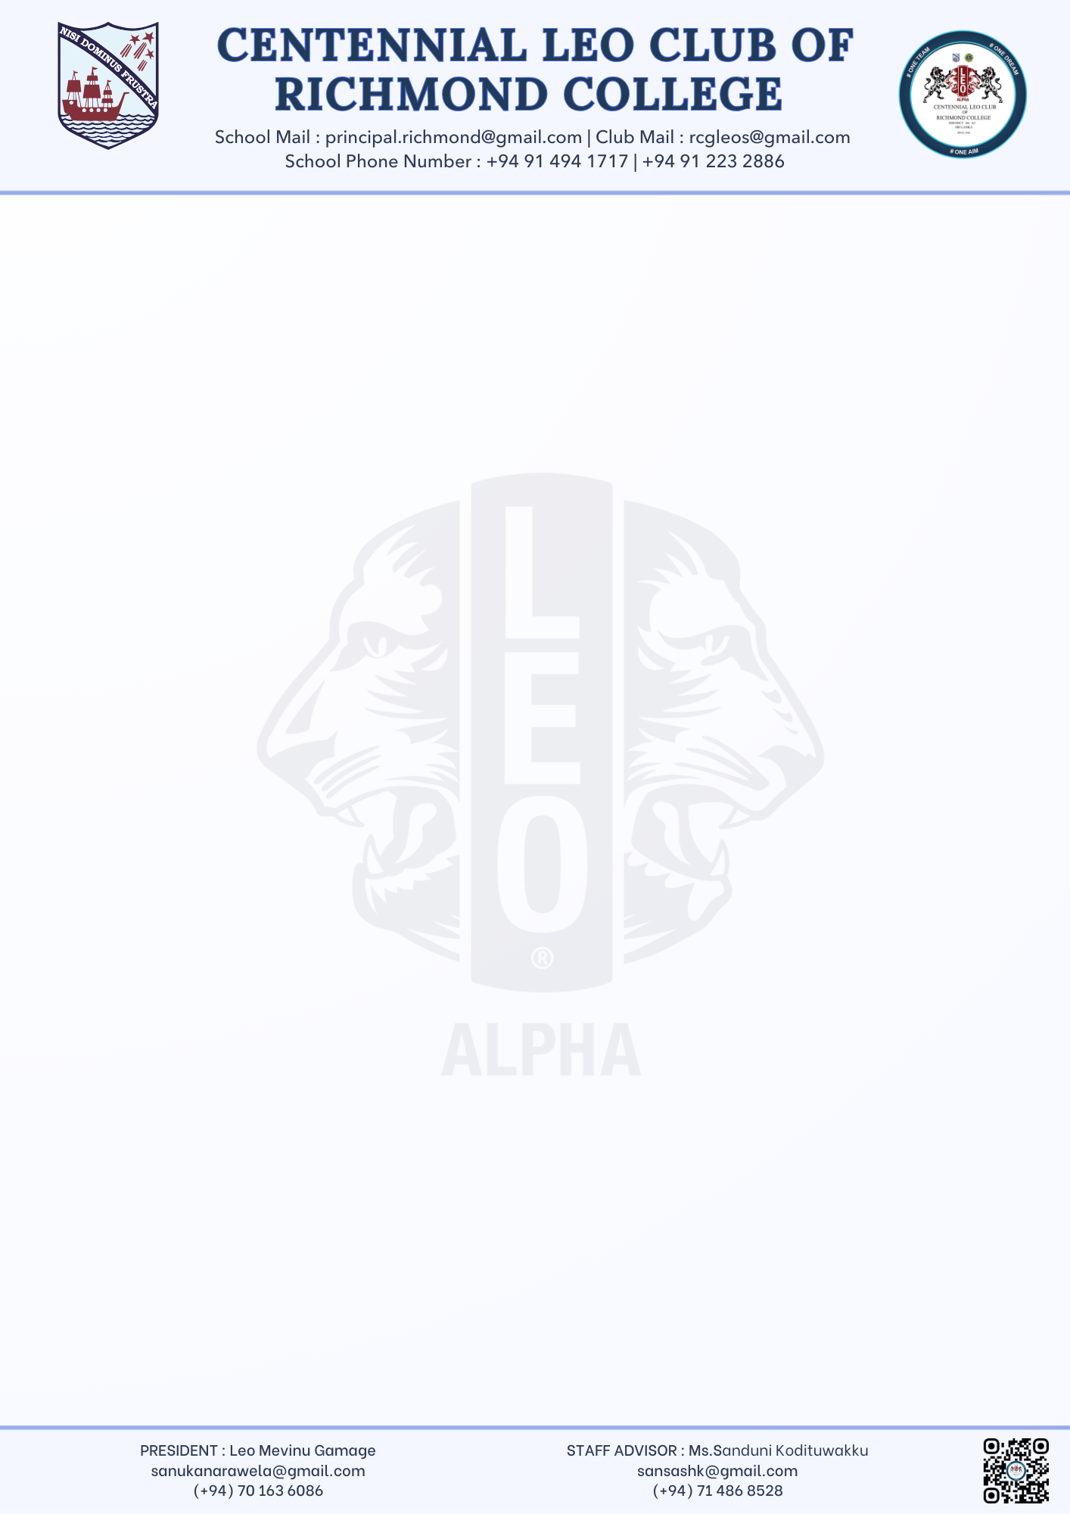
Mevinu Gamage,
President
Centennial Leo Club of Richmond College, Galle
26.09.2025
Principal
Richmond College, Galle
Dear Sir,
Submission of Project Proposal for “INSPIRATION’25” – 10th Installation Ceremony
We, the Centennial Leo Club of Richmond College, Galle, are pleased to inform you that our club will be organizing its 10th Installation Ceremony under the name “INSPIRATION’25” on 25th of October .
As advised, we kindly submit herewith the Project Proposal of the event for your kind perusal and approval.
We look forward to your valuable guidance and support in making this milestone event a success.
Thank you.
Yours faithfully,

………………………………………
Mevinu Sanuka Narawela Gamage
President
Centennial Leo Club of Richmond College

………………………………………
Ms. Sanduni Kodituwakku
Staff Advisor
Centennial Leo Club of Richmond College

